The National University of Lesotho
Department of Mathematics and Computer Science
Faculty of Science and technology

CS4433: Software Engineering
Task: Phase 2: System Design
Due: 18/10/2026
Participants:
 | Student Number | Surname, initials | Major
 | 202322467 | Lephoto L. | B. Sc. Information Systems

System Architecture

A layered architecture separates user interaction, business rules, and persistence. This supports testing and maintenance and prevents assessment rules from being buried in menu code.
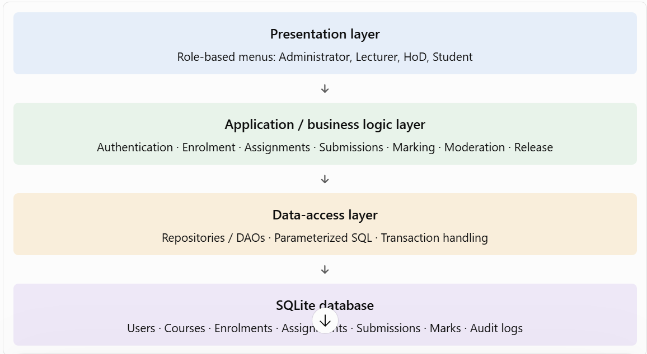

Component Diagram
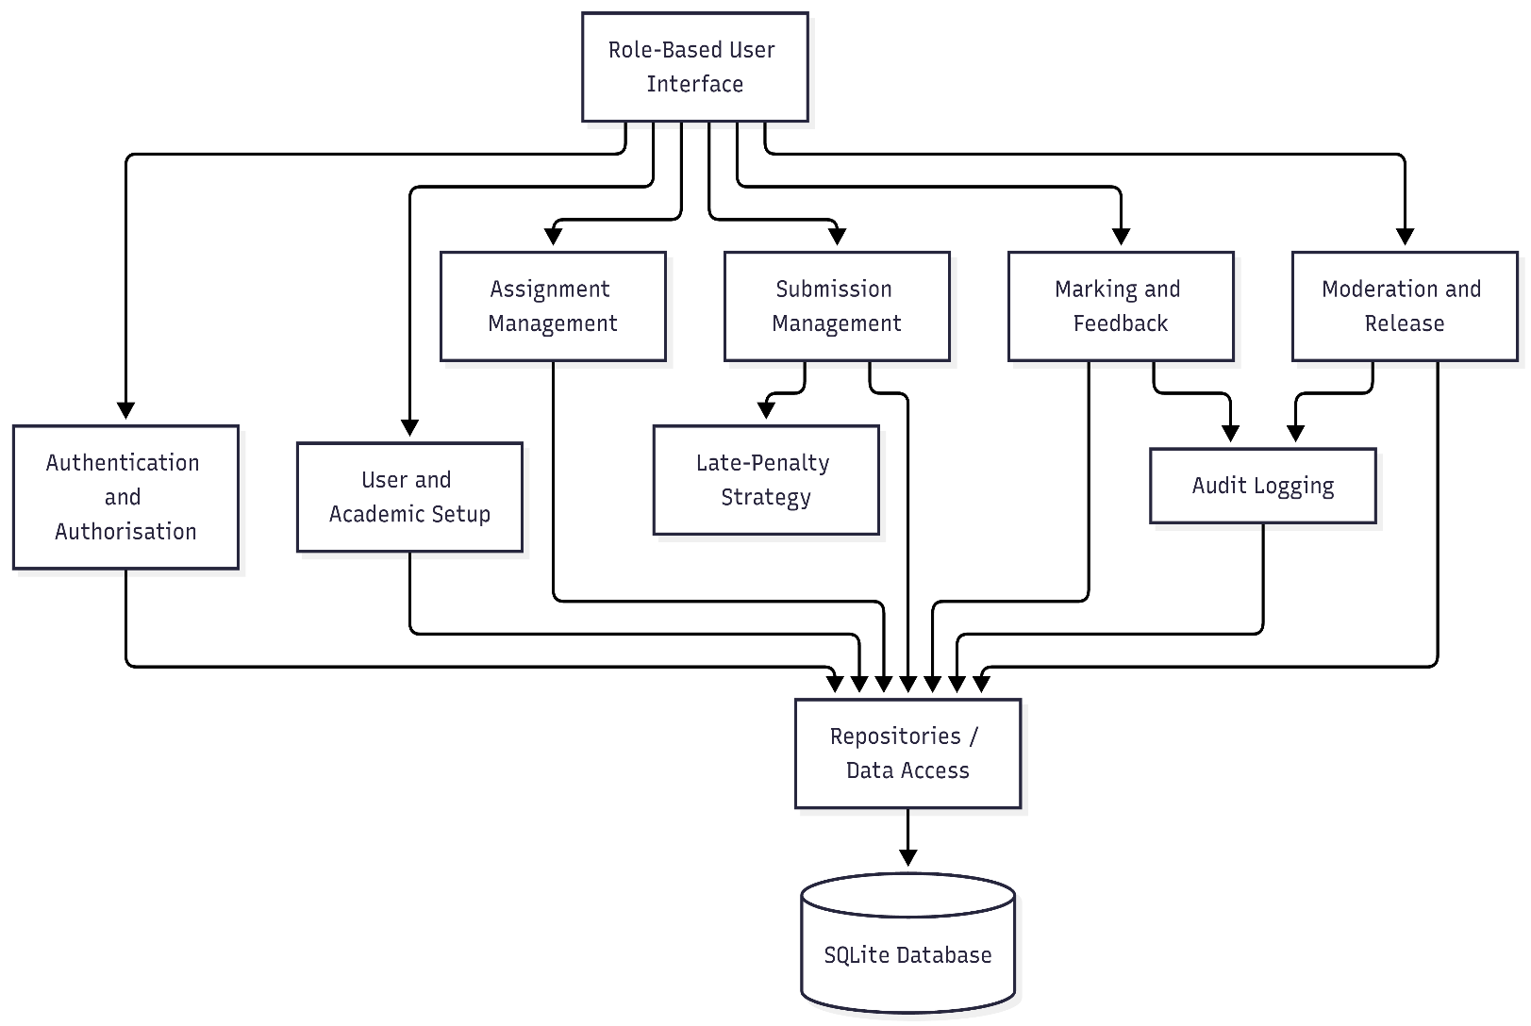

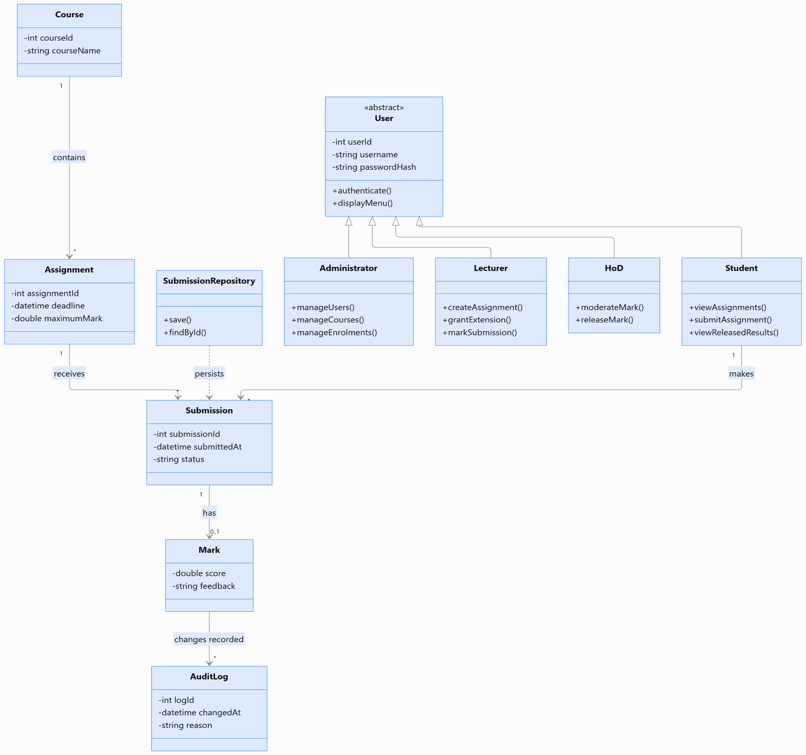
Class Diagram

Pattern | Proposed use | Benefit
Strategy | Different late-penalty calculation policies | The penalty rule can change without rewriting submission processing.
Observer | Notify relevant application components when a mark is approved or released | Helps separate the release process from related updates, if this event-based design is needed.

2.1 SOLID Principle
Principle | Application to LMS
Single Responsibility | SubmissionService manages submission rules; SubmissionRepository handles persistence.
Open/Closed | The Strategy pattern allows penalty policies to be extended without changing the submission workflow.
Liskov Substitution | Each user subclass should be usable wherever the system expects a User, without breaking expected behaviour.
Interface Segregation | Keep interfaces focused—for example, avoid requiring students to implement administrator-only operations.
Dependency Inversion | Business services should depend on repository interfaces rather than directly constructing SQLite operations throughout the application.

Behavioural models

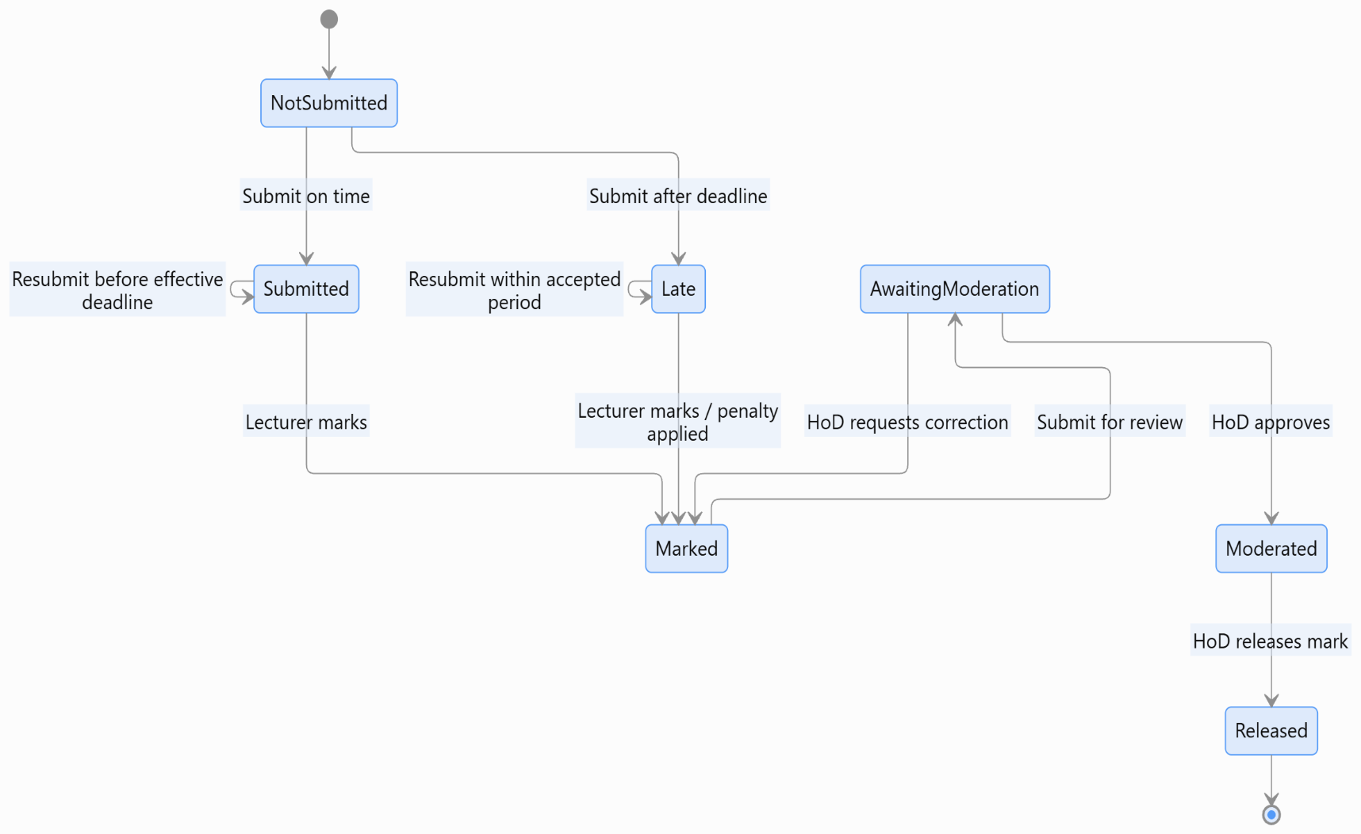
3.1 State Machine Diagram

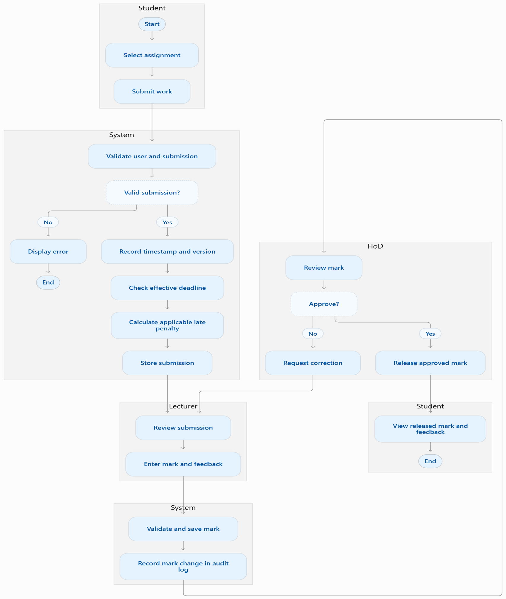
3.2 Activity Diagram

3.3 Sequence Diagrams

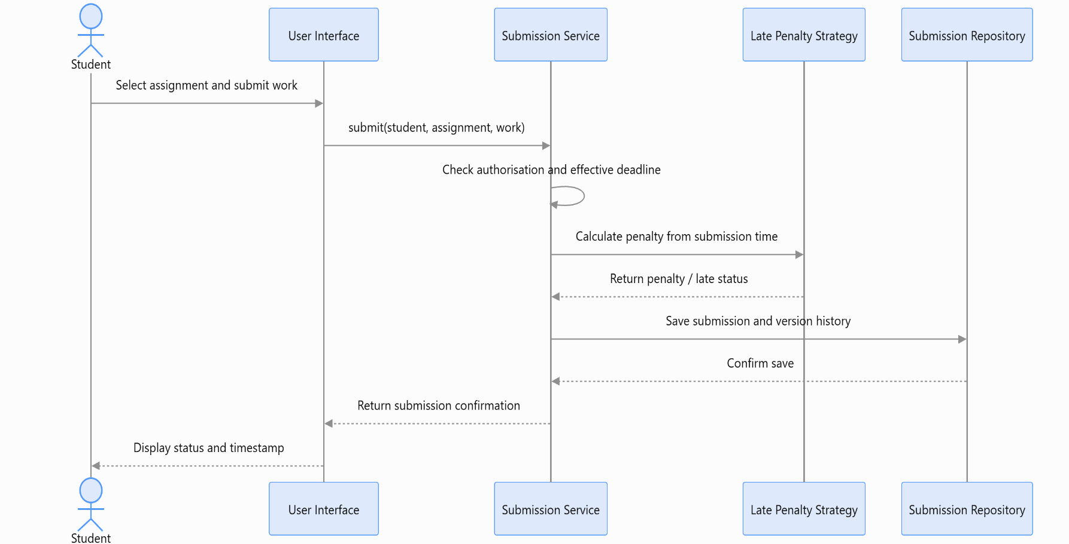
3.3.1 Submit assignment

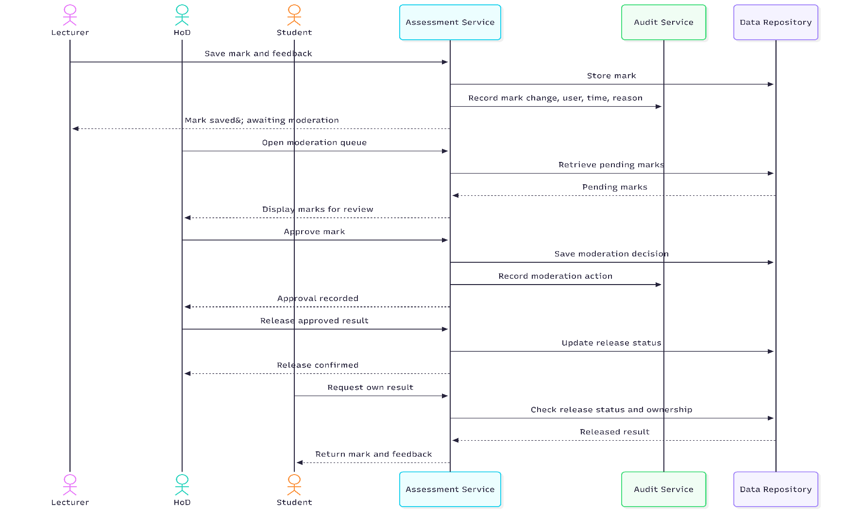
3.3.2 Moderate and release marks

4. Database design

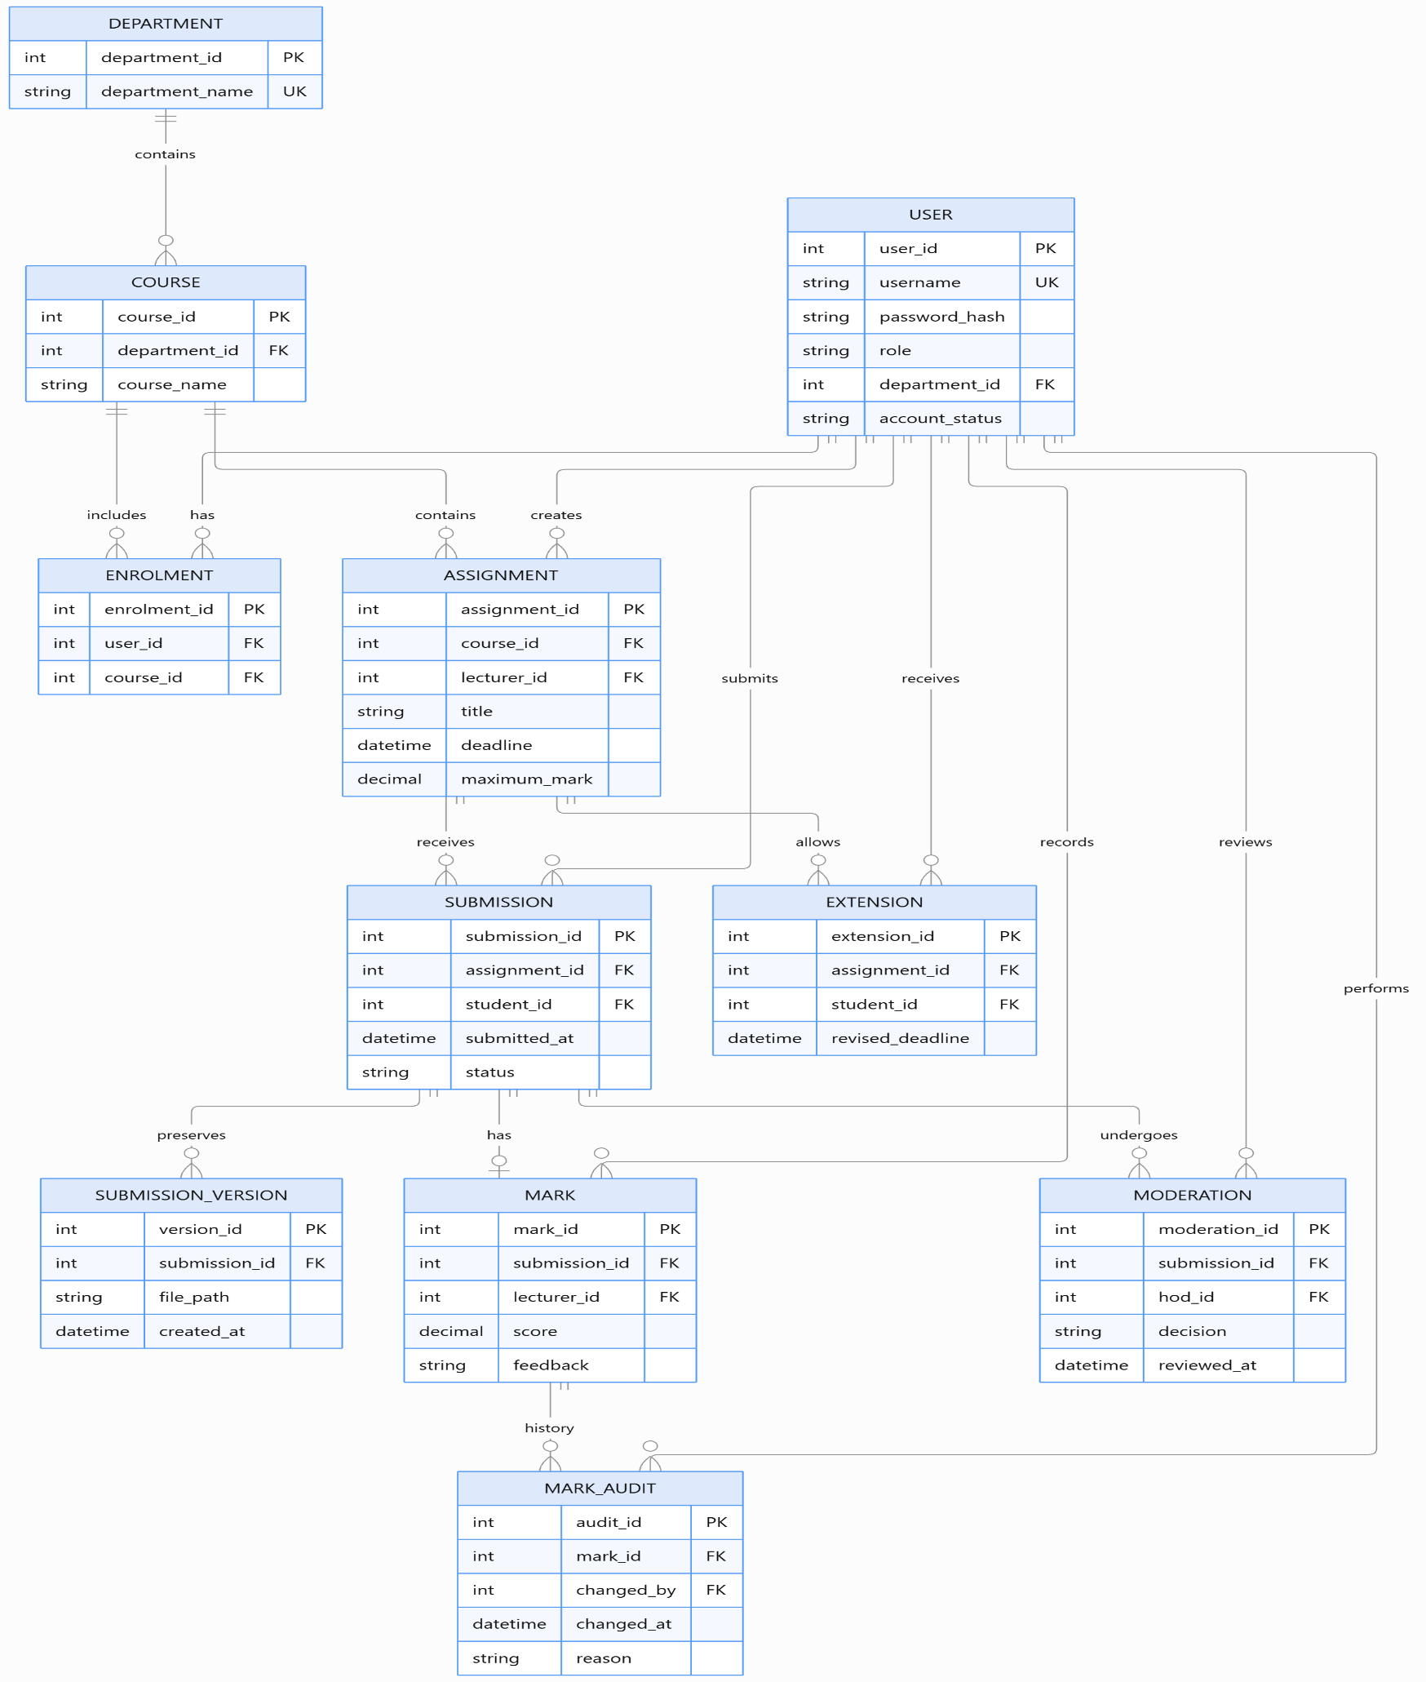
4.1 ERD
Table | Important fields | Purpose / constraints
USER | user_id, username, password_hash, role | Unique account; username must be unique; never store plaintext passwords.
DEPARTMENT | department_id, department_name | Stores school departments; department name should be unique.
COURSE | course_id, department_id, course_name | Each course belongs to a department.
ENROLMENT | enrolment_id, user_id, course_id | Links students to courses; the user/course combination must be unique.
ASSIGNMENT | assignment_id, course_id, lecturer_id, deadline, maximum_mark | Defines an assessment and its deadline and maximum mark.
SUBMISSION | submission_id, assignment_id, student_id, submitted_at, status | Records the student's submission and current workflow status.
SUBMISSION_VERSION | version_id, submission_id, file_path, created_at | Preserves each submitted version.
MARK | mark_id, submission_id, lecturer_id, score, feedback | Stores the current mark and feedback.
MARK_AUDIT | audit_id, mark_id, changed_by, changed_at, reason | Provides a traceable record of mark changes.
MODERATION | moderation_id, submission_id, hod_id, decision, reviewed_at | Records moderation decisions.
EXTENSION | extension_id, assignment_id, student_id, revised_deadline | Records individual deadline extensions.

4.2 Data Dictionary

4.3 SQL Schema
PRAGMA foreign_keys = ON;

CREATE TABLE Department (
department_id INTEGER PRIMARY KEY,
department_name TEXT NOT NULL UNIQUE
);

CREATE TABLE User (
user_id INTEGER PRIMARY KEY,
username TEXT NOT NULL UNIQUE,
password_hash TEXT NOT NULL,
role TEXT NOT NULL CHECK (
role IN ('Admin', 'Lecturer', 'HoD', 'Student')
),
department_id INTEGER,
account_status TEXT NOT NULL DEFAULT 'Active'
CHECK (account_status IN ('Active', 'Inactive')),
FOREIGN KEY (department_id)
REFERENCES Department(department_id)
);

CREATE TABLE Course (
course_id INTEGER PRIMARY KEY,
department_id INTEGER NOT NULL,
course_name TEXT NOT NULL,
FOREIGN KEY (department_id)
REFERENCES Department(department_id),
UNIQUE (department_id, course_name)
);

CREATE TABLE Enrolment (
enrolment_id INTEGER PRIMARY KEY,
student_id INTEGER NOT NULL,
course_id INTEGER NOT NULL,
FOREIGN KEY (student_id) REFERENCES User(user_id),
FOREIGN KEY (course_id) REFERENCES Course(course_id),
UNIQUE (student_id, course_id)
);

CREATE TABLE Assignment (
assignment_id INTEGER PRIMARY KEY,
course_id INTEGER NOT NULL,
lecturer_id INTEGER NOT NULL,
title TEXT NOT NULL,
instructions TEXT NOT NULL,
deadline TEXT NOT NULL,
maximum_mark REAL NOT NULL CHECK (maximum_mark > 0),
FOREIGN KEY (course_id) REFERENCES Course(course_id),
FOREIGN KEY (lecturer_id) REFERENCES User(user_id)
);

CREATE TABLE Submission (
submission_id INTEGER PRIMARY KEY,
assignment_id INTEGER NOT NULL,
student_id INTEGER NOT NULL,
submitted_at TEXT NOT NULL,
status TEXT NOT NULL CHECK (
status IN (
'Submitted', 'Late', 'Marked',
'AwaitingModeration', 'Moderated', 'Released'
)
),
FOREIGN KEY (assignment_id)
REFERENCES Assignment(assignment_id),
FOREIGN KEY (student_id) REFERENCES User(user_id),
UNIQUE (assignment_id, student_id)
);

CREATE TABLE SubmissionVersion (
version_id INTEGER PRIMARY KEY,
submission_id INTEGER NOT NULL,
file_path TEXT NOT NULL,
created_at TEXT NOT NULL,
FOREIGN KEY (submission_id)
REFERENCES Submission(submission_id)
);

CREATE TABLE Mark (
mark_id INTEGER PRIMARY KEY,
submission_id INTEGER NOT NULL UNIQUE,
lecturer_id INTEGER NOT NULL,
score REAL NOT NULL CHECK (score >= 0),
feedback TEXT NOT NULL,
FOREIGN KEY (submission_id)
REFERENCES Submission(submission_id),
FOREIGN KEY (lecturer_id) REFERENCES User(user_id)
);

CREATE TABLE MarkAudit (
audit_id INTEGER PRIMARY KEY,
mark_id INTEGER NOT NULL,
changed_by INTEGER NOT NULL,
changed_at TEXT NOT NULL,
reason TEXT NOT NULL,
old_score REAL,
new_score REAL NOT NULL,
FOREIGN KEY (mark_id) REFERENCES Mark(mark_id),
FOREIGN KEY (changed_by) REFERENCES User(user_id)
);

CREATE TABLE Moderation (
moderation_id INTEGER PRIMARY KEY,
submission_id INTEGER NOT NULL,
hod_id INTEGER NOT NULL,
decision TEXT NOT NULL CHECK (
decision IN ('Approved', 'CorrectionRequired')
),
reviewed_at TEXT NOT NULL,
reason TEXT,
FOREIGN KEY (submission_id)
REFERENCES Submission(submission_id),
FOREIGN KEY (hod_id) REFERENCES User(user_id)
);

CREATE TABLE Extension (
extension_id INTEGER PRIMARY KEY,
assignment_id INTEGER NOT NULL,
student_id INTEGER NOT NULL,
revised_deadline TEXT NOT NULL,
granted_by INTEGER NOT NULL,
FOREIGN KEY (assignment_id)
REFERENCES Assignment(assignment_id),
FOREIGN KEY (student_id) REFERENCES User(user_id),
FOREIGN KEY (granted_by) REFERENCES User(user_id),
UNIQUE (assignment_id, student_id)
);

